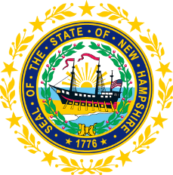

STATEWIDE INDEPENDENT LIVING COUNCIL

September 18, 2019--11:30 a.m. – 2:30 p.m.

Granite State Independent Living

21 Chenell Drive, Concord, NH

AGENDA

Jeff Dickinson, Chair

11:30am – 12:30 pm * Meetings of SPIL Implementation Task Forces

12:30 – 1:00 pm * Luncheon

1:00 – 2:30 pm SILC Meeting

- Introductions and Roll Call
- Review of April 17 and June 19 minutes – Jeff Dickinson
- Working Together Conference- Susan Wolf-Downes
- Introduction of Daniel Frye- Daniel Frye and Jeff Dickinson
- Recognition of new members- Jeff Dickinson
- Overview of the SPIL progress- Tobey Partch-Davies
- Conference Presentation Opportunity – Jen Beaulieu
- Membership Outreach
- Other business
- Adjournment

NEXT SILC MEETING –Wednesday, November 13, 2019 at Walker Building, 21South Fruit Street, Concord, NH.

