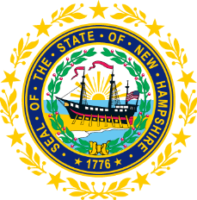

STATEWIDE INDEPENDENT LIVING COUNCIL

November 20, 2019--11:30 a.m. – 2:30 p.m.

Granite State Independent Living

21 Chenell Drive, Concord, NH

AGENDA

Jeff Dickinson, Chair

11:30am – 12:30 pm * Meetings of SPIL Implementation Task Forces

12:30 – 1:00 pm * Luncheon

1:00 – 2:30 pm SILC Meeting

- Introductions and Roll Call
- Guest Speaker and Q&A
Nicole McKenzie
U.S. Census
-Nicole McKenzie will discuss the upcoming Census and their employment opportunities.
- Review of September 18th minutes – Jeff Dickinson
- Discussion and Questions on Bylaws
  - Do Ex-Officios need to be voted in?
  - Will Ex-Officios have term limits?
  - Do our Bylaws follow the federal law and regulations?
- Discussion on SPIL Status and Task Force Reports
- Working Together Conference Report
- Membership Outreach
- Other business
- Adjournment

NEXT SILC MEETING –Wednesday, January 15, 2020 at TBD
(Snow Day on Wednesday, January 22, 2020 at TBD)

