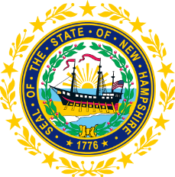

STATEWIDE INDEPENDENT LIVING COUNCIL

November 14, 2018--11:30 a.m. – 2:30 p.m.

Walker Building 1st Floor, Room 100

21 South Fruit Street, Concord, NH

AGENDA

Jeff Dickinson, Chair

11:30am – 12:30 pm * Meetings of SPIL Implementation Task Forces

12:30 – 1:00 pm * Luncheon

1:00 – 2:30 pm SILC Meeting

- Introductions and Roll Call
- Review and Approval of September Minutes – Jeff Dickinson
- Reports of SPIL Implementation Task Forces
  - All taskforces: Updates on changes on timelines for activities
  - Expansion of IL Services in the State – Peggy Teravainen, Chair
  - Expansion of Accessible and Affordable Transportation – Jeff Dickinson and Marcia Golembeski, Co-Chairs
  - School to Work and Nursing Home Transition Services – Susan Wolf-Downes and Deb Lindsey
- Membership – Jeff Dickinson
  - Diversity of members
  - Recruiting new members
  - Reappointments and appointments
- 2020-2022 SPIL – Jeff Dickinson and Tobey Partch-Davies
- DSE Update – Bill Finn
- GCD Updates – Chuck Saia and/or Lorrie Ripley
- Collaboration with Other Agencies – Jeff Dickinson and Jen Beaulieu
- Other business
- Dates for upcoming meetings
- Adjournment

NEXT SILC MEETING –Wednesday, February 20th, 2019
- Snow date Wednesday, February 27th, 2019

