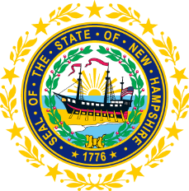

STATEWIDE INDEPENDENT LIVING COUNCIL

September 26, 2018--11:30 a.m. – 2:30 p.m.

Walker Building 1st Floor, Room 100

21 South Fruit Street, Concord, NH

AGENDA

Jeff Dickinson, Chair

11:30am – 12:30 pm * Meetings of SPIL Implementation Task Forces

12:30 – 1:00 pm * Luncheon

1:00 – 2:30 pm SILC Meeting

- Introductions and Roll Call
- Review and Approval of June Minutes – Jeff Dickinson
- Reports of SPIL Implementation Task Forces
  - Expansion of IL Services in the State – Peggy Teravainen, Chair
  - Expansion of Accessible and Affordable Transportation – Jeff Dickinson and Marcia Golembeski, Co-Chairs
  - School to Work and Nursing Home Transition Services – Susan Wolf-Downes and Deb Lindsey
- Membership – Jeff Dickinson
- Website and Social Media– Jen Beaulieu
- SPIL – Jeff Dickinson
- Mission/Vision
- DSE Update – Bill Finn
- Collaboration with Other Agencies – Jeff Dickinson and Jen Beaulieu
- Other business
- Adjournment

NEXT SILC MEETING –Wednesday, November, 14 2018

