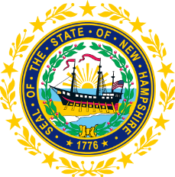

STATEWIDE INDEPENDENT LIVING COUNCIL

September 16, 2020 1:00 p.m. – 2:30 p.m.

ZOOM

AGENDA

Carrie Dudley, Chair

1:00 – 2:30 pm SILC Meeting

- Introductions and Roll Call
- Approval of Minutes of 5/20 Full SILC Meeting
- Recognition of Andrew Harmon’s Service to the NH SILC
- Bylaws Discussion
- SPIL Discussion
  - 2017-2020 SPIL
  - 2021-2023 SPIL
- Other Business & Announcements
- Adjournment

NEXT SILC MEETING –Wednesday, November 18th on ZOOM

