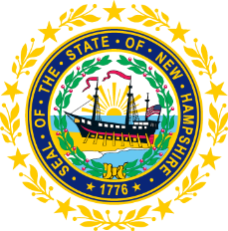

STATEWIDE INDEPENDENT LIVING COUNCIL

May 18, 2022 12:30 p.m. – 2:30 p.m.

Granite State Independent Living

21 Chenell Drive, Concord, NH

AGENDA

Carrie Dudley, Chair

As the chair of this council, Carrie will follow the federal health emergency guidelines as it relates to the rising cases of COVID and allow this body to be remote with the ability to meet with quorum while being remote.

12:30 – 1:00 pm Arrival and Luncheon
1:00 – 2:30 pm SILC Meeting

- Introductions and Roll Call
- Approval of Minutes of 3/16 Full SILC Meetings
- Committee Updates
  - Membership
  - Governance
  - Advocacy
- Recognition of Marcia Golembeski service to the NH SILC
- Vote and Q & A on Applicants
- Other Business
- Adjournment

NEXT SILC MEETING –Wednesday, July 20, 2022 at GSIL

