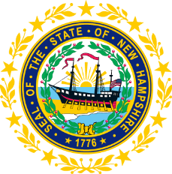

STATEWIDE INDEPENDENT LIVING COUNCIL
ADVOCACY COMMITTEE MEETING
Online
November 26, 2025 – 2:30 p.m.

Andrew Harmon, Committee Chair

Agenda:

- Welcome and Call to Order - Andrew Harmon
- Benefits Counseling Presentation- Deanna Johnson, Community Crossroads of NH
- Review Minutes from October 22 Meeting
- Discussion of Medicaid Work Requirements from Federal and State Legislation in 2025
- Review of SPIL Objectives
  - Goal 1 Objectives
  - Discussion regarding Outreach and/or Future Panel Discussion
  - Goal 5 Objectives
- Brief Discussion on Voting Access during Local City Elections
- Other Business
- Adjourn

