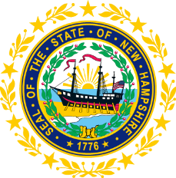

STATEWIDE INDEPENDENT LIVING COUNCIL
ADVOCACY COMMITTEE MEETING
Online
October 22, 2025 – 2:30 p.m.

Andrew Harmon, Committee Chair

Agenda:

- Welcome and Call to Order - Andrew Harmon
- Presentation on Benefits Counseling- Kristin Venator, VR
- Review of September 24th and 30th Meeting Minutes
- Discussion regarding Upcoming Advocacy Committee Dates for November and December
- SPIL Goals and Objectives Updates
  - Goal 1 objectives/211 Discussion- Sarah Sweeney and Jennifer Cook
  - Objective 4.3- Andrew Harmon
  - Goal 5 Objectives- Andrew Harmon
- Legislative Discussion- Mo Baxley and Ryan Donnelly
- Other Business
- Adjourn

