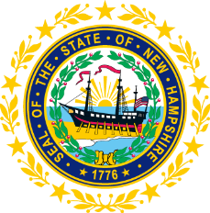

STATEWIDE INDEPENDENT LIVING COUNCIL
EXECUTIVE COMMITTEE MEETING
Online
October 15, 2025 – 1:30-2:30 p.m.

Randy Pierce, Chair
Agenda:
- Call-To-Order – Randy Pierce
- Approval of August 20, 2025 EC Meeting Minutes
- Status Update on GSIL’s Subcontract out to Other Part-B Vendors
- Status Update on DSE/Governor Appointment Submission
- Sarah Sweeney Proposal for Membership Cap
- Discussion on Change of Calendar for NH SILC to Reflect Federal Fiscal Year
- Discussion on Agenda for Full SILC Meeting on 11/19
  - Education/Presentation idea (TEAP?)
  - PPR Reminder/Discussion
  - Presentation of Part B Survey Results?
  - SPIL Alert (Only Concerns not In-Progress Updates)
  - Vote on Edited Policies and Procedures?
- Other Business
- Adjournment

