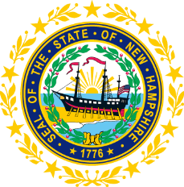

STATEWIDE INDEPENDENT LIVING COUNCIL
MEMBERSHIP COMMITTEE MEETING
Online
February 17, 2026 – 2:00 p.m.

Duration: 60 Minutes
Chair: Ryan Witterschein

Agenda:
- Call to Order and Welcome (5 minutes)
The committee chair will call the meeting to order and welcome all members and guests. A brief roll call will be conducted to establish attendance and confirm quorum for committee business.

- Discussion on Succession Planning (10 minutes)

- Approval of Previous Meeting Minutes (5 minutes)
The committee will review and approve the minutes from the previous membership committee meeting. Any corrections or amendments will be addressed before final approval.

- Current Membership Status Report (10 minutes)
The committee will receive an update on current NH SILC membership composition, including consumer representation, geographic distribution, and any recent changes in membership status. This report will include analysis of compliance with federal requirements for SILC membership structure.

- Recruitment and Outreach Initiatives (15 minutes)
Discussion of ongoing efforts to recruit new members, particularly focusing on maintaining appropriate consumer representation and ensuring geographic diversity across New Hampshire. The committee will review current outreach strategies and identify potential candidates for membership consideration.

- Member Orientation and Development (5 minutes)
Brief review of orientation processes for new members and ongoing professional development opportunities for current members. Discussion of resource needs and training priorities for effective committee participation.

- Action Items and Next Steps (20 minutes)
Review of specific action items identified during the meeting, assignment of responsibilities, and confirmation of deadlines. Planning for next committee meeting date and agenda priorities.

- Adjournment (1 minute)
Formal adjournment of the meeting.

