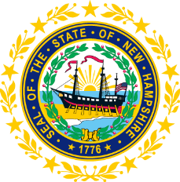

STATEWIDE INDEPENDENT LIVING COUNCIL
ADVOCACY COMMITTEE MEETING
Online
January 28, 2026 – 2:30 p.m.

Andrew Harmon, Committee Chair

Agenda:

- Welcome and Call to Order - Andrew Harmon
- Presentation on Benefits planning - Deanna Johnson, Community Crossroads of NH
- Review of November 26th meeting minutes
- Review of SPIL Objectives:
  - Goal 1 objectives - Andrew Harmon
  - Discussion of 4.3 and reminder to review previous recordings/power-point slides
  - Goal 5 objectives - Andrew Harmon
- NH Legislation update - Ryan Donnelly and Mo Baxley
- Other business
- Adjourn

