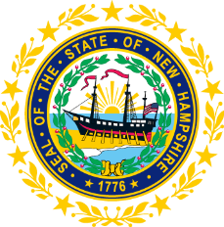

STATEWIDE INDEPENDENT LIVING COUNCIL
ADVOCACY COMMITTEE MEETING
Online
March 18, 2026 – 2:30 p.m.

Andrew Harmon, Committee Chair

Agenda:

- Welcome and Call to Order- Andrew Harmon
- Review of February 25th Meeting Minutes
- Discussion of SPIL Objectives:
  - Goal 1
  - Objective 4.3 Framework for Outreach Presentation
  - Update on Ad-hoc Committee
- Discussion of Immediate Past and Upcoming Local Municipal Elections regarding Accessible Voting
- Legislative Updates
- Other Business
- Adjourn

