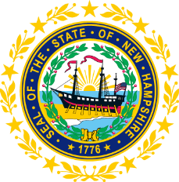

STATEWIDE INDEPENDENT LIVING COUNCIL

March 18, 2026, 12:30 p.m. – 2:30 p.m.

Lunch 12:30-1:00
Meeting 1:00-2:30

Hearing Room, NH Commission for Human Rights Office

57 Regional Drive, Suite #8

Communications Access:
In Person meeting with advanced access to virtual when necessitated

AGENDA

- Welcome and Introductions/Roll Call
- Approval of Minutes of 1/21 Full SILC Meeting
- DSE Update-Lisa Beck
- Committee Updates
  - Membership
  - Governance
  - Advocacy
- SPIL Goal Review
- Ad Hoc Requests
- Other Business
- Adjournment

NEXT SILC MEETING –Wednesday, May 20, 2026
Voting Members:

Ryan Witterschein (Acting Chair)

Deborah Ritcey (Second Vice-Chair)

Krystal Chase (Acting Secretary)

Member Isadora Rodriguez-Legendre

Member Jennifer Cook

Member Ryan Donnelly

Member Andrew Harmon

Member Michelle McConaghy

Member Joshua Gehling

Member Robert Kallin

Staff:

Jennifer Beaulieu (SILC Assistant)

