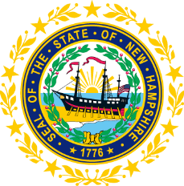

STATEWIDE INDEPENDENT LIVING COUNCIL
EXECUTIVE COMMITTEE MEETING
Online
April 15, 2026 – 1:30-2:30 p.m.

Ryan Witterschein, Acting Chair
Agenda:
- Call-To-Order – Ryan Witterschein
- Approval of February 18, 2026 EC Meeting Minutes
- DSE Update
- PPR Update
- SPIL Review
  - SPIL Document Table
- Discussion on Exhibiting at SCC Conference
- Discussion on Agenda for Full SILC Meeting on 5/20
  - Education/Presentation idea? (Northeast Deaf and Hard of Hearing Services, Inc.)
  - SPIL Review
- Other Business
- Adjournment

