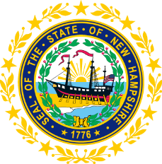

STATEWIDE INDEPENDENT LIVING COUNCIL
ADVOCACY COMMITTEE MEETING
Online
April 22, 2026 – 2:30 p.m.

Andrew Harmon, Committee Chair

Agenda:

- Welcome and Call to Order- Andrew Harmon
- Review and Approval of March 25th Meeting Minutes
- SPIL Review:
  - Goal 1 Discussion
  - Objective 4.3 Review for Fall Presentations
  - Ad-hoc Update for Goal 5 Objectives
- Legislative Updates-Ryan Donnelly and Mo Baxley
- Other Business
- Adjourn

