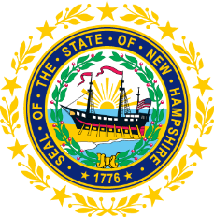

STATEWIDE INDEPENDENT LIVING COUNCIL
ADVOCACY COMMITTEE MEETING
Online
May 27, 2026 – 2:00 p.m.

Andrew Harmon, Committee Chair

Agenda:

- Welcome and Call to Order- Andrew Harmon
- Review and Approval of April 22nd Meeting Minutes
- SPIL Goals/Objectives Discussion
  - Goal 1 Discussion- Ryan Donnelly
  - 4.4 Framework Discussion- Andrew Harmon
  - Ad-hoc Committee Update- Andrew Harmon
- Transportation Updates- Andrew Harmon
- Other Legislative Updates-Ryan Donnelly and Mo Baxley
- Other Business
- Summer Meeting Schedule-Andrew Harmon
- Adjourn

