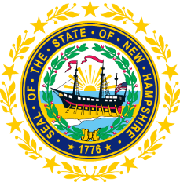

STATEWIDE INDEPENDENT LIVING COUNCIL
MEMBERSHIP COMMITTEE MEETING
Online
July 21, 2026 – 2:00 p.m.

Duration: 60 Minutes
Chair: Ryan Witterschein

Agenda:
- Call to Order
- Approval of Meeting Minutes (6/16/26)
- Introduction of Applicant; Nathalie Frontier
- Discussion on Current Membership Challenges
- Updates on Pending Appointments
- Next Steps regarding Recruitment and Onboarding Efforts
- Update on Joshua Gehling’s and Isadora Rodriguez-Legendre’s Membership
- Discussion on Any Recommendations that came out of the Governor Committee Discussions
- Other Business
- Adjournment

