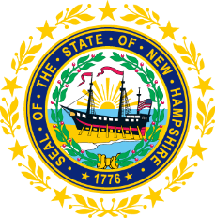

STATEWIDE INDEPENDENT LIVING COUNCIL
ADVOCACY COMMITTEE MEETING
Online
June 24, 2026 – 2:00 p.m.

Andrew Harmon, Committee Chair

Agenda:

- Welcome and Call to Order- Andrew Harmon
- Review of May 25th Meeting Minutes- Andrew Harmon
- Check-in on SPIL Goals/Objectives:
  - Goal 1 Objectives- Andrew Harmon
  - Objective 4.3 Presentation Progress Updates- Ryan Donnelly
  - Ad-hoc Committee Update- Andrew Harmon
- Disability Round-Table Updates- Andrew Harmon and Mo Baxley
- Other Business
- Adjourn

