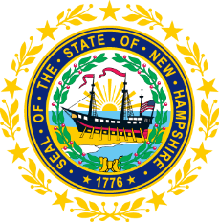

STATEWIDE INDEPENDENT LIVING COUNCIL
ADVOCACY COMMITTEE MEETING
Online
July 22, 2026 – 2:00 p.m.

Andrew Harmon, Committee Chair

Agenda:

- Welcome and Call to Order- Andrew Harmon
- Review of June 24th Meeting Minutes
- Overview of SPIL Updates
  - Goal 1 Objectives
  - Objective 4.3 Presentation Progress
  - Updates on Ad-Hoc committee regarding Goal 5 objectives
- Quick update on Disability Round-Table group now known as NH LEAF (NH League for an Equitable and Accessible Future)
- Discussion on OSERS and potential impact on SILC/NH
- Other Business
- Adjourn

