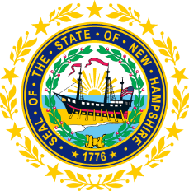

STATEWIDE INDEPENDENT LIVING COUNCIL

July 15, 2026, 12:30 p.m. – 2:30 p.m.

Lunch 12:30-1:00
Meeting 1:00-2:30

Hearing Room, NH Commission for Human Rights Office

57 Regional Drive, Suite #8

Communications Access:
In Person meeting with advanced access to virtual when necessitated

AGENDA

- Welcome and Introductions/Roll Call
- Approval of Minutes of 5/20 Full SILC Meeting
- Q&A and Vote on Applicant: Micheal Negrete
- DSE Update-Lisa Beck
- Officer Election Update
- Reminder that Part B Vendor Surveys Need to be Done by October 1
- Committee Updates
  - Membership
  - Governance
  - Advocacy
- Other Business
- Adjournment

NEXT SILC MEETING –Wednesday, September 16, 2026
Voting Members:

Ryan Witterschein (Acting Chair)

Deborah Ritcey (Second Vice-Chair)

Krystal Chase (Acting Secretary)

Member Ryan Donnelly

Member Andrew Harmon

Member Michelle McConaghy

Member Robert Kallin

Staff:

Jennifer Beaulieu (SILC Assistant)

