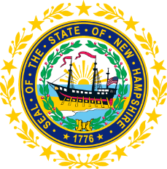

STATEWIDE INDEPENDENT LIVING COUNCIL

June 19, 2019--11:30 a.m. – 2:30 p.m.

Walker Building

21 South Fruit Street, Concord, NH

AGENDA

Jeff Dickinson, Chair

11:30am – 12:30 pm * Meetings of SPIL Implementation Task Forces

12:30 – 1:00 pm * Luncheon

1:00 – 2:30 pm SILC Meeting

- Introductions and Roll Call
- Guest Speaker & Q&A
Susan Wolf-Downes and staff
Northeast Deaf and Hard-of-Hearing Services
-Susan will discuss programs that NDHHS offers.
- Demo of ZOOM for the SPIL public input sessions
- Review and Approval of April Minutes – Jeff Dickinson
- Election of New Officers
- Discussion on meeting with Lisa Hatz on VR/SPIL/Budget matters
- Review of Application of Ellie Kimball
- *Time Permitting* Reports of SPIL Implementation Task Forces
  - Expansion of IL Services in the State – Peggy Teravainen, Chair
  - Expansion of Accessible and Affordable Transportation – Jeff Dickinson and Marcia Golembeski, Co-Chairs
  - School to Work and Nursing Home Transition Services- Susan Wolf-Downes
- Other business
- Adjournment

NEXT SILC MEETING –Wednesday, September 18, 2019 at Granite State Independent Living on 21 Chenell Drive in Concord, NH.

