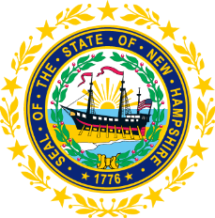

STATEWIDE INDEPENDENT LIVING COUNCIL

June 27, 2018--11:30 a.m. – 2:30 p.m.

Walker Building 1st Floor, Room 100

21 South Fruit Street, Concord, NH

AGENDA

Jeff Dickinson, Chair

11:30am – 12:30 pm * Meetings of SPIL Implementation Task Forces (Mandatory)
12:30 – 1:00 pm * Luncheon

1:00 – 2:30 pm SILC Meeting

- Introductions and Roll Call
- Review and Approval of April Minutes – Jeff Dickinson
- Elections
- Reports of SPIL Implementation Task Forces
  - Expansion of IL Services in the State – Peggy Teravainen, Chair
  - Expansion of Accessible and Affordable Transportation – Jeff Dickinson and Marcia Golembeski, Co-Chairs
  - School to Work and Nursing Home Transition Services – Susan Wolf-Downes and Deb Lindsey
- Mission/Vision
- Part B Discussion-Jeff Dickinson and Bill Finn
  - State level
  - Federal Level
- SILC Policies and Procedures Work Group Report – Erin Hall and Dorine Pelletier
- DSE Update – Bill Finn
- Report of the GCD- Charles Saia, Esq., Executive Director
- Legislative Report- Jeff Dickinson
- Recruitment
- Other business
- Adjournment

NEXT SILC MEETING –Wednesday, September, 26 2018

