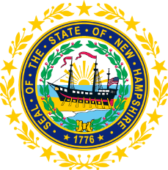

STATEWIDE INDEPENDENT LIVING COUNCIL

July 19, 2023, 12:30 p.m. – 2:30 p.m.

Room 100, Walker Building

21 South Fruit Street

AGENDA

Voting Members: Carrie Dudley (Chair), Deborah Ritcey (First Vice-Chair), Randy Pierce (Second Vice-Chair), Jeff Dickinson (Immediate Past Chair and Secretary), Jennifer Cook, Erin Hall, Michelle McConaghy, Sarah Sweeney, and Ryan Witterschein

Staff:

Jennifer Beaulieu (SILC Assistant) and Lisa Hatz (Designated State Entity Representative)

Guests:

Matthew Goodness (Nominee), Matthew Greenwood (Member of the Public), Laurie Meyer (ASL Interpreter), and Rebekah Mallory (ASL Interpreter)

12:30 – 1:00 pm Arrival and Luncheon
1:00 – 2:30 pm SILC Meeting

- Introductions and Roll Call
- Approval of Minutes of 3/15 and 5/17 Full SILC Meeting
- Committee Updates
  - Membership
  - Governance
  - Advocacy
- Bylaws Presentation and Vote to Amend
- SPIL Progress
- Report out on Findings regarding other SILC websites
- Vote and Q & A of Applicant Matthew Goodness?
- Other Business
- Adjournment

NEXT SILC MEETING –Wednesday, September 20, 2023 at Walker Building

