Section 7: DSE Assurances

(name of DSE director/representative) acting on behalf of the DSE (Insert name of DSE) located at (insert address, phone number, and e-mail address) 45 CFR 1329.11 assures that:

  - The DSE acknowledges its role on behalf of the State, as the fiscal intermediary to receive, account for, and disburse funds received by the State to support Independent Living Services in the State based on the plan;

  - The DSE will assure that the agency keeps appropriate records, in accordance with federal and state law, and provides access to records by the federal funding agency upon request;

  - The DSE will not retain more than 5 percent of the funds received by the State for any fiscal year under Part B for administrative expenses;vi

  - The DSE assures that the SILC is established as an autonomous entity within the State as required in 45 CFR 1329.14;

  - The DSE will not interfere with the business or operations of the SILC that include but are not limited to:
    - Expenditure of federal funds
    - Meeting schedules and agendas
    - SILC board business
    - Voting actions of the SILC board

    - Personnel actions
    - Allowable travel
    - Trainings

  - The DSE will abide by SILC determination of whether the SILC wants to utilize DSE staff:
    - If the SILC informs the DSE that the SILC wants to utilize DSE staff, the DSE assures that management of such staff with regard to activities and functions performed for the SILC is the sole responsibility of the SILC in accordance with Sec. 705(e)(3) of the Act (Sec. 705(e)(3), 29 U.S.C.796d(e)(3)).

  - The DSE will fully cooperate with the SILC in the nomination and appointment process for the SILC in the State;

  - The DSE shall make timely and prompt payments to Part B funded SILCs and CILs:
    - When the reimbursement method is used, the DSE must make a payment within 30 calendar days after receipt of the billing, unless the agency or pass-through entity reasonably believes the request to be improper;
    - When necessary, the DSE will advance payments to Part B funded SILCs and CILs to cover its estimated disbursement needs for an initial period generally geared to the mutually agreed upon disbursing cycle; and
    - The DSE will accept requests for advance payments and reimbursements at least monthly when electronic fund transfers are not used, and as often as necessary when electronic fund transfers are used, in accordance with the provisions of the Electronic Fund Transfer Act (15 U.S.C. 1693-1693r).

The signature below indicates this entity/agency’s agreement to: serve as the DSE and fulfill all the responsibilities in Sec. 704(c) of the Act; affirm the State will comply with the aforementioned assurances during the three-year period of this SPIL; and develop, with the SILC, and ensure that the SILC resource plan is necessary and sufficient (in compliance with section 8, indicator (6) below) for the SILC to fulfill its statutory duties and authorities under Sec. 705(c) of the Act, consistent with the approved SPIL.vi
Lisa Hinson-Hatz, VR Director
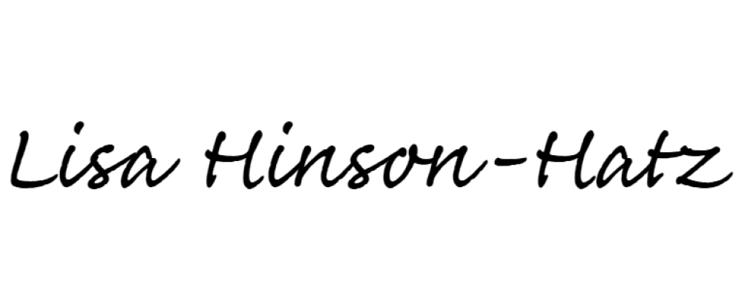
Name and Title of DSE director/authorized representative
6/30/23
Signature Date

Electronic signature may be used for the purposes of submission, but hard copy of signature must be kept on file by the SILC.

Section 8: Statewide Independent Living Council (SILC) Assurances and Indicators of Minimum Compliance

  - Assurances
Carrie Dudley acting on behalf of the SILC of New Hampshire
located at c/o Governor's Commission on Disability, Suite 5, 54 Regional Drive, Concord, NH,
603-520-8195, careervisions1@aol.com
45 CFR 1329.14 assures that:
    - The SILC regularly (not less than annually) provides the appointing authority recommendations for eligible appointments;
    - The SILC is composed of the requisite members set forth in the Act;vi
    - The SILC terms of appointment adhere to the Act;vi
    - The SILC is not established as an entity within a State agency in accordance with 45 CFR Sec. 1329.14(b);
    - The SILC will make the determination of whether it wants to utilize DSE staff to carry out the functions of the SILC;
      - The SILC must inform the DSE if it chooses to utilize DSE staff;
      - The SILC assumes management and responsibility of such staff with regard to activities and functions performed for the SILC in accordance with the Act.vi
    - The SILC shall ensure all program activities are accessible to people with disabilities;
    - The State Plan shall provide assurances that the designated State entity, any other agency, office, or entity of the State will not interfere with operations of the SILC, except as provided by law and regulation and;
    - The SILC actively consults with unserved and underserved populations in urban and rural areas that include, indigenous populations as appropriate for State Plan development as described in Sec. 713(b)(7) the Act regarding Authorized Uses of Funds.vi

Section 8.2 Indicators of Minimum Compliance
Indicators of minimum compliance for Statewide Independent Living Councils (SILC) as required by the Rehabilitation Act (Section 706(b), 29 U.S.C. Sec 796d-1(b)), as amended and supported by 45 CFR 1329.14-1329.16; and Assurances for Designated State Entities (DSE) as permitted by Section 704(c)(4) of the Rehabilitation Act (29 U.S.C. Sec. 796c(c)(4)), as amended.

- STATEWIDE INDEPENDENT LIVING COUNCIL INDICATORS. –

  - SILC written policies and procedures must include:
    - A method for recruiting members, reviewing applications, and regularly providing recommendations for eligible appointments to the appointing authority;
    - A method for identifying and resolving actual or potential disputes and conflicts of interest that are in compliance with State and federal law;

    - A process to hold public meetings and meet regularly as prescribed in 45 CFR 1329.15(a)(3);
    - A process and timelines for advance notice to the public of SILC meetings in compliance with State and federal law and 45 CFR 1329.15(a)(3);
    - A process and timeline for advance notice to the public for SILC “Executive Session” meetings, that are closed to the public, that follow applicable federal and State laws;
      - “Executive Session” meetings should be rare and only take place to discuss confidential SILC issues such as but not limited to staffing.
      - Agendas for “Executive Session” meetings must be made available to the public, although personal identifiable information regarding SILC staff shall not be included;
    - A process and timelines for the public to request reasonable accommodations to participate during a public Council meeting;
    - A method for developing, seeking and incorporating public input into, monitoring, reviewing and evaluating implementation of the State Plan as required in 45 CFR 1329.17; and
    - A process to verify centers for independent living are eligible to sign the State Plan in compliance with 45 CFR 1329.17(d)(2)(iii).
  - The SILC maintains regular communication with the appointing authority to ensure efficiency and timeliness of the appointment process.
  - The SILC maintains individual training plans for members that adhere to the SILC Training and Technical Assistance Center’s SILC training curriculum.
  - The SILC receives public input into the development of the State Plan for Independent Living in accordance with 45 CFR 1329.17(f) ensuring:
    - Adequate documentation of the State Plan development process, including but not limited to, a written process setting forth how input will be gathered from the state’s centers for independent living and individuals with disabilities throughout the state, and the process for how the information collected is considered.
    - All meetings regarding State Plan development and review are open to the public and provides advance notice of such meetings in accordance with existing State and federal laws and 45 CFR 1329.17(f)(2)(i)-(ii);
    - Meetings seeking public input regarding the State Plan provides advance notice of such meetings in accordance with existing State and federal laws, and 45 CFR 1329.17(f)(2)(i);
    - Public meeting locations, where public input is being taken, are accessible to all people with disabilities, including, but not limited to:
      - proximity to public transportation,
      - physical accessibility, and

      - effective communication and accommodations that include auxiliary aids and services, necessary to make the meeting accessible to all people with disabilities.
    - Materials available electronically must be 508 compliant and, upon request, available in alternative and accessible format including other commonly spoken languages.
  - The SILC monitors, reviews and evaluates the State Plan in accordance with 45 CFR 1329.15(a)(2) ensuring:
    - Timely identification of revisions needed due to any material change in State law, state organization, policy or agency operations that affect the administration of the State Plan approved by the Administration for Community Living.
  - The SILC State Plan resource plan includes:
    - Sufficient funds received from:
      - Title VII, Part B funds;
        - If the resource plan includes Title VII, Part B funds, the State Plan provides justification of the percentage of Part B funds to be used if the percentage exceeds 30 percent of Title VII, Part B funds received by the State;
      - Funds for innovation and expansion activities under Sec. 101(a)(18) of the Act, 29 U.S.C. Sec. 721(a)(18), as applicable;
      - Other public and private sources.
    - The funds needed to support:
      - Staff/personnel;
      - Operating expenses;
      - Council compensation and expenses;
      - Meeting expenses including meeting space, alternate formats, interpreters, and other accommodations;
      - Resources to attend and/or secure training and conferences for staff and council members and;
      - Other costs as appropriate.

The signature below indicates the SILC’s agreement to comply with the aforementioned assurances and indicators:
Carrie Dudley
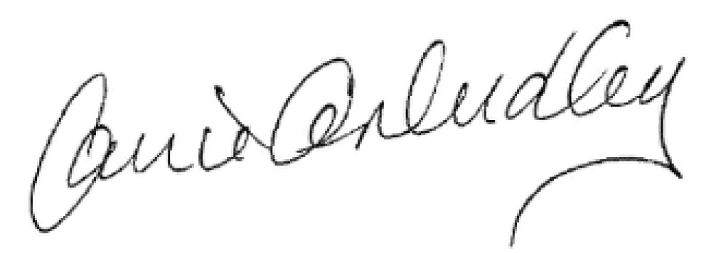
Name of SILC chairperson
Signature
6/30/23
Date

Electronic signature may be used for the purposes of submission, but hard copy of signature must be kept on file by the SILC.

Section 9: Signatures

The signatures below are of the SILC chairperson and at least 51 percent of the directors of the centers for independent living listed in section 6.3. These signatures indicate that the New Hampshire Statewide Independent Living Center and the centers for independent living in the state agree with and intend to fully implement this SPIL’s content. These signatures also indicate that this SPIL is complete and ready for submission to the Independent Living Administration, Administration for Community Living, U.S. Department of Health and Human Services.
The effective date of this SPIL is October 1,
2023
(year)
SIGNATURE OF SILC CHAIRPERSON
6/30/23
DATE

Carrie Dudely
NAME OF SILC CHAIRPERSON
Granite State Independent Living
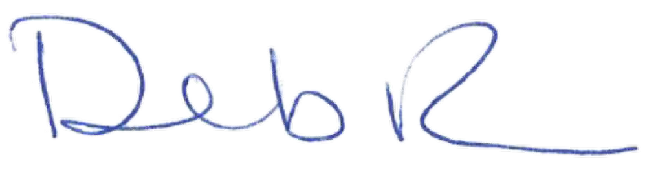
NAME OF CENTER FOR INDEPENDENT LIVING (CIL)
6/30/23
SIGNATURE OF CIL DIRECTOR DATE
Deborah Ritcey
NAME OF CIL DIRECTOR

NAME OF CENTER FOR INDEPENDENT LIVING (CIL)

SIGNATURE OF CIL DIRECTOR DATE

NAME OF CIL DIRECTOR

NAME OF CENTER FOR INDEPENDENT LIVING (CIL)

SIGNATURE OF CIL DIRECTOR DATE

NAME OF CIL DIRECTOR

NAME OF CENTER FOR INDEPENDENT LIVING (CIL)

SIGNATURE OF CIL DIRECTOR DATE

NAME OF CIL DIRECTOR
(INSERT ADDITIONAL CILS AS NEEDED)

Electronic signatures may be used for the purposes of submission, but hard copy of signature must be kept on file by the SILC.

